Project 1 Documentation

Table of Contents

A. Overview of Project Requirements 3
1.0 Introduction 3
2. General Description 5
3. Requirements 8
3A. Functional Requirements 8
3B. Non-Functional Requirements 13
B. Selection of Process Model 16
C. Analysis Model 17
C1. Overview 17
C2. Use Case Diagrams & Descriptions 18
C3. Class Diagrams 32
D. Design Documentation 33
D1. Interface Design 33
D2. Architectural Design 39
D3. Data Design 40
E. Testing Documentation 43
F. Proposal for Project Module 2 44
G. Implementation Schedule 45
Appendix A - Process Diagrams 46

A. Overview of Project Requirements

1.0 Introduction

Purpose
This is a requirements document for a member registration system for a county rowing club association. The primary goal of the project is to create a registration system whereby all affiliated members details can be registered on a web-based system and regatta results can be recorded on same.

Scope of this document
This document and the system described in it were created by the author for the county rowing club Association and the rowing clubs affiliated to that Association. The requirements were designed using specifications given by the committee of the county rowing club Association, which also includes members of the affiliated rowing clubs.

Overview
Section 1 (this section) is an overview and introduction to this requirements document. Section 2 is a general overview of the system. Section 3 includes the specific requirements and their details. The document was designed using the IEEE/ANSI 830---1993 as given by the class lecturer.

1.4 Definitions, Acronyms, and Abbreviations
- Association: the county rowing club association
- Affiliated Club: A rowing club which is affiliated with the Association and competing in the area covered by the county rowing club association
- Club Secretary: A person in an affiliated club who is responsible for recording his/her clubs registered members, recording winners of their club’s annual regatta, distributing these results to other clubs, and validating their club’s teams in the All-Ireland championships.
- Club Chairperson: The Chairperson of an Affiliated Club. In the absence of the Club Secretary, the Club Chairperson would assume the responsibilities of the Club Secretary.
- Member: any person who has paid a membership fee to an Affiliated Club and is deemed by the Club Secretary to be a member of that Affiliated Club. Note that a Club Secretary and a Club Chairperson would be a Member of their own club.
- Users: Club Secretaries, Club Chairpersons who are registered users.
- GAA: Gaelic Athletic Association.
- System Administrator: point of contact for the Rowing Association in case of any system difficulties or queries.

1.5 References
  - “Requirements Engineering Processes and Techniques”, Gerald Kotonya and Ian Somerville, 1998, John Wiley & Sons Ltd, England.
  - The Gaelic Athletic Association (GAA)’s registration system on the web site www.gaa.ie.

2. General Description

Product Perspective
There are five rowing clubs affiliated to the Association. The Club Secretaries currently record member’s details on either Microsoft Excel spreadsheets or Microsoft Word documents on their own personal computers at home. They record regatta results on paper on the day. Three secretaries record these details on spreadsheets, print out the results and distribute them to the other secretaries in the club by hand or by post. Two secretaries photocopy the results sheet they fill in on the day of the regatta and distribute the results to the other club secretaries by hand or by post.

Product Functions
To create a web-based registration system to implement the following functions
- store members details
- record regatta results
- run a report to check how many regattas a member has participated in
- allow regatta results to be viewed by members of the public on the web site

Similar System Information
This system will be used by Club Secretaries to replace the existing paper-based system (as described in 2.1 Product Perspective). The system was designed with both the existing system and a similar system in mind. This similar system is the GAA’s registration system, implemented in 2005.

User Characteristics
This system will be used by Club Secretaries and Club Chairpersons to replace an existing system (as described in 2.1 Product Perspective). The system was designed with both the existing system and a similar system in mind. This similar system is the GAA’s registration system, implemented in 2005.
The Club Secretaries and Club Chairpersons who will utilize the registration system have limited use of the kind of system that will be required to solve the problem that is specified in this document, and that should be remedied by training them before system implementation.
The general public will also be able to access the website to view regatta results. This will be simple in comparison to the above Users' use of the system and no training would be required in this instance.

User Problem Statement
The Club Secretaries and Club Chairpersons find that the current paper-system is onerous; there is a lot of duplication of work that would be solved by using the up-to-date technology.

User Objectives
The primary goal is to register all club members’ details in one place so that they will be available to others. The secondary goal is that regatta results can be stored and accessed in one system and that reports can be run to see how many regattas a member competed in.

Stakeholders
The stakeholders for this project are
- the Association
- the affiliated clubs
- the affiliated club’s secretaries
- the affiliated club’s chairperson
The chief stakeholders for this project are the Club Secretaries and Club Chairpersons as they will be using the system and completely changing the way they have done this task in the past

General Constraints
The system must be capable of being implemented and completely functional by 1st June 2007 in order to be ready for the beginning of the regatta season. The client has also expressed that cost should be kept to a minimum, as the association and all the clubs affiliated to it, are run on a voluntary basis. Also the client requested that the training could be provided on a flexible schedule as Club Secretaries and Chairpersons have normal job schedules to work around.

Assumptions and Dependencies
- The requirements here assume that each Club Secretary and Club Chairperson have a personal computer from which they can access the system.
- It also assumes that each Club Secretary and Club Chairperson is willing to use this system, or can nominate another member of their affiliated club to use the system.
- Another assumption is that the Users will receive adequate training to utilize the system.

3. Requirements

3A. Functional Requirements

The System Shall Allow Users to Upload Member Information
    - Description The Users can fill in a Microsoft Excel spreadsheet with member information and then upload this spreadsheet on the web. They will download this standard spreadsheet from the web initially as it will be designed in a format that the system can read. In this way the Users can collate all member information before logging on to the system again and therefore do not have to spend a lot of time on the web filling in details. Three users already use Microsoft Excel spreadsheets to record this information at present. This is similar to the GAA’s registration system.
The specific users must enter the name, address and date of birth of the member. If this information is missing for any member the system will reject the upload of the information and point out to the user where the problem is and how to rectify it.
The user can add another member or members at a later date by submitting the spreadsheet again with the new member/members details on it.
Please see Appendix A.3 for a diagrammatic representation.
3.1.2 Criticality
Very Important.

    - Technical Issues
This requirement will require a database for the member information.
    - Cost and Schedule
This is the most expensive part of the system, and the most critical.
    - Risks
If all the information isn’t available for a member then the system will reject the entire upload. If is up to the User to get this information and proceed will the upload.
    - Dependencies with Other Requirements
Requirement 3.9.

The System Shall Allow Users to Update Member Information
    - Description The Users can update member details stored in database for their own club only. The user will be prompted with a message to confirm the update before it takes place.
    - Criticality
Important.
    - Technical Issues
This requirement will require a database for the member information.
    - Cost and Schedule
This is a normal database function.
    - Risks
The user must be careful not to update members’ details by accident. A prompt will be given before the update is made to ask the user if they are sure about the update.
    - Dependencies with Other Requirements
Requirement 3.9.

The System Shall Determine Possibilities of Duplicate Members Details and Inform the User of Such a Possibility
    - Description If a user uploads a members information and this member’s name already exists the system will alert the user to this and either offer ask the user if he/she wants to overwrite the existing members details or create a new member (it is of course a possibility that two members in a club will have the same name).
Please see Appendix A.3 for a diagrammatic representation.

    - Criticality
Very Important.
    - Technical Issues
This requirement will require a database for the member information.
    - Cost and Schedule
This requirement will have a minimal cost.
    - Risks
None.
    - Dependencies with Other Requirements
Requirement 3.9.

The System Shall Allow Users to Input Regatta Results
    - Description The user can input the results of their annual regatta on the system using electronic forms; that is, a data sheet that exists as a computer interface by which the user can type in details. The user will
- select regatta name from a drop down list
- type in the date
- select race from a drop down list e.g. Under 14 Girls
- select placing from a drop down list i.e. first, second, third, fourth, fifth, sixth, seventh, eighth.
- select each member from a drop down list. This list will contain all members from all clubs that would qualify for that age group i.e. for the Under 14 Girls the drop down list will contain all female members less than 14 years of age.
- select club from a drop down list
Please see Appendix A.4 for a diagrammatic representation.
    - Criticality
Very Important.
    - Technical Issues
This requirement will require a database for the member information.
    - Cost and Schedule
Forms are relatively inexpensive to implement.
    - Risks
It may happen that a team will have members from more than one club. The system will allow the user to write free form text into the ‘Club’ field to cater for this situation.
In practice a person may take part in a regatta who is not a member of any club affiliated to the Association. The results function will allow free form text to be entered to cater for this situation also.
When the users are being trained it will be stressed that they should select names/clubs from the drop down lists where possible and only use the free form text option if absolutely necessary.
    - Dependencies with Other Requirements
Requirement 3.9.

The System Shall Allow Users to Create a Report on How Many Regattas a Member Participated in During the Season
    - Description For a particular member a user will be able to run a report to determine how many regattas that member took part in during the rowing season, and what percentage this is of the total number of regattas. This is required as a member must have taken part in 75% or more of their own Association’s regattas to be allowed to compete in the All-Ireland competition. Select a member from a drop down list. This list will contain all members from all clubs that would qualify for that age group i.e. for the Under 14 Girls the drop down list will contain all female members under 14 years of age.
Please see Appendix A.5 for a diagrammatic representation.
    - Criticality
Very Important.
    - Technical Issues
This requirement will require a database for the member information.
    - Cost and Schedule
All this information will exist in the system already so the cost is minimal.
    - Risks
It may occur that a team will have members from more than one club.
    - Dependencies with Other Requirements
Requirement 3.9.

The System Shall Give Access to the General Public to See Association Related Information on the Website
    - Description The system will give access to the general public to view Association related information such as Event Information, Regatta Results and contact details for each affiliated club.
    - Criticality
Important.
    - Technical Issues
None.
    - Cost and Schedule
Cost will be minimal.
    - Risks
None.
    - Dependencies with Other Requirements
None.

3B. Non-Functional Requirements

The System Shall Be Accessed via a Standard Web Browser
    - Description The web based system will be accessed Netscape version 4.0 or higher, or Internet Explorer version 4.0 or higher.
    - Criticality
Very Important.
    - Technical Issues
This version of HTML is compatible with Netscape version 4.0 or higher, and Internet Explorer version 6.
    - Cost and Schedule
This is will have a minimal cost as a person’s personal computer would have this as standard.
    - Risks
None.
    - Dependencies with Other Requirements
Requirement 3.8.

The System Interface Shall be Written in HTML
    - Description
The system interface will be written in HTML using the Dreamweaver tool.
See Appendix A.1 and A.2 for a login process diagram and sample user interface.
    - Criticality
Very Important.
    - Technical Issues
None.
    - Cost and Schedule
This is available at present.
    - Risks
None.
    - Dependencies with Other Requirements
The version of Dreamweaver used must be compatible with the web browsers to be used (Requirement 3.7).

The System Shall Have a Database to Hold and Manage All Registrations
    - Description The system will have a database to store all the member’s information and regatta results.
    - Criticality
Very Important.
    - Technical Issues
The database will be chosen based on cost and suitability to the size of the new system.
    - Cost and Schedule
All this information will exist in the system already so the cost is minimal.
    - Risks
It may happen that a team will have members from more than one club.
    - Dependencies with Other Requirements
Requirements 3.7 and 3.8.

The System Shall Restrict Access to Club Member’s Personal Details to Registered Users
    - Description The system will restrict access to member’s personal details to registered users as data will be stored on the system about minors. Only two club members per club will have access to the system. Each club will have approximately fifty members less than 18 years of age.
    - Criticality
Very Important.
    - Technical Issues
Implementing security has yet to be examined in close detail. A password protected system at present is the preferred method.
    - Cost and Schedule
Password protecting the system will be cheap.
    - Risks
The parents of minors may not want their children’s names, addresses and dates of birth on the web. The security will need to be very high to convince parents to agree to this.
    - Dependencies with Other Requirements
Requirement 3.1

B. Selection of Process Model

I have decided to use the Unified Process Model for the following reasons:
!. It is use case driven. This project is best understood by looking at the Use Cases
2. It is architecture centric. A main learning process for me is to understand the client-server architecture so a model which supports this is appropriate.
3. It is incremental and iterative. Project 2 will focus on prototyping different implementations and so it is expected that changes will need to be made after each prototyping stage. The first prototype will features the basic functions of the system and other functions will be added on.

C. Analysis Model

C1. Overview
Use Case Diagrams, Use Case Descriptions, Class Diagrams and screen mock ups will be used to depict the requirements of the new system. They will refer back to the Requirements outlined in Section A – Overview of Project Requirements.

C2. Use Case Diagrams & Descriptions
User in the Use case descriptions refers to the Registered User in Section A Overview of Project Requirements.
C2.1. Use Case Diagram
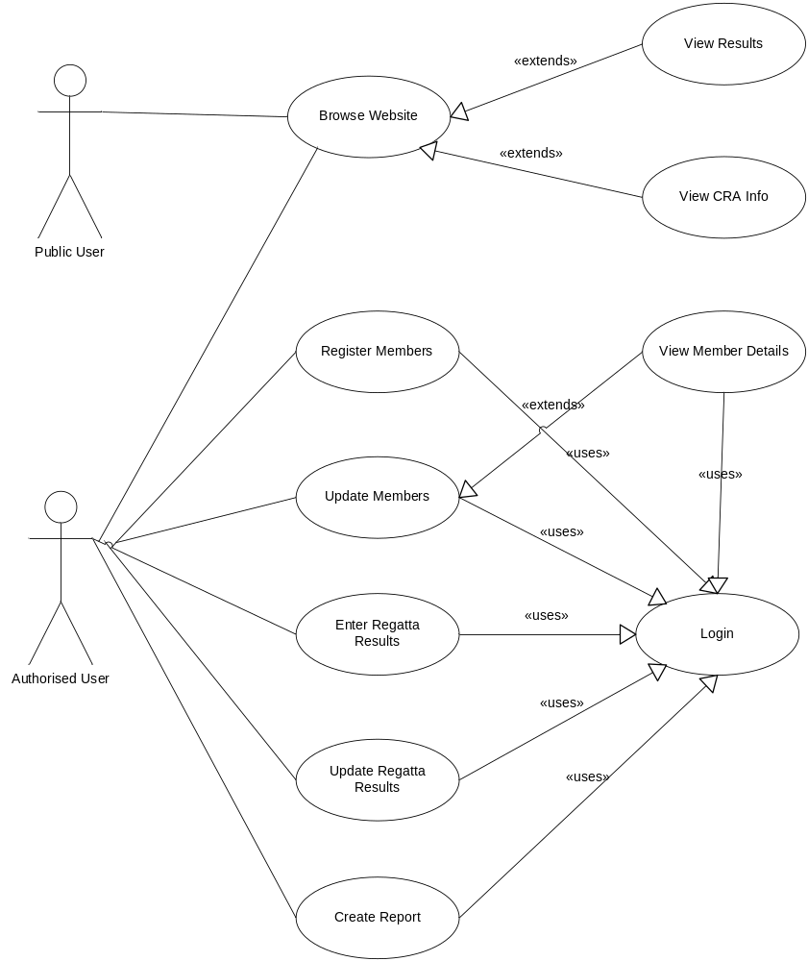

C2.2. Use Case Descriptions

Use Case Name: Browse Website |  | ID: 1 | Importance Level: High
Primary Actor: Member of Public (MoP), User | Use Case Type: Detail
Stakeholders and Interests:
MoPs, User: need to be able to get information about the CRA from the website.
CRA: wants accurate data publishes on the website to publicise the work of the CRA.

Brief Description:
This use case describes how a MoP can access details about the CRA.

Trigger:
MoP logs on to www.cra.com.

Type:
External
Relationships:
Association:
Include:
Extend:
Generalization:
Normal Flow of Events:
1. MoP goes to the website www.cra.com.
2. The MoP can view information on the main page itself. This will contain Recent and Upcoming Events news.
3. The MoP can select the History link to see information on the history of the Association and the clubs affiliated to the Association.
4. The MoP can select the Regatta Results link to view regatta results. In this case the S-1 Regatta Results subflow is performed.
5. The MoP can select the Contact Us link to retrieve information on Association contacts.
6. The MoP can select the Links link to bring us a list of links of relevant information. This information has not been decided upon yet. It is envisaged that when other clubs set up websites their links will appear here.
7. When the MoP selects any of the above links, the resultant page will have a Home Page link to return the MoP back to the home page of the Association.

Subflows:
S:1: Regatta Results
- The MoP will be presented with the View Regatta Results screen.
- The MoP will be prompted to select the Year and Club name from drop down lists, then hit enter.
- The system will present the Regatta Details in a spreadsheet format. The MoP shall be able to scroll through all the Regatta Results.
- The MoP will select the Return to Previous Page button, where he/she can select another set of regatta results.

Alternate/Exceptional Flows:
1. If the user selects the Year name but not the Club name, the system will prompt the user to select the Club name.
2. If the user selects the Club name but not the Year, name the system will prompt the user to select the Year.

Figure C2.2.1 Browse Website Use Case Description

Use Case Name: View Regatta Results |  | ID: 2 | Importance Level: High
Primary Actor: Member of Public (MoP), User | Use Case Type: Detail
Stakeholders and Interests:
MoPs: want to check Regatta results.
Users: also want to check Regatta results without having to log on to the Registered Users section.
CRA: wants accurate data publishes on the website to publicise the work of the CRA.

Brief Description:
This use case describes how a MoP can access details about the CRA.

Trigger:
MoP logs on to www.cra.com.

Type:
External
Relationships:
Association:
Include: Login
Extend: Browse Website
Generalization:
Normal Flow of Events:
1. The MoP will be presented with the View Regatta Results screen.
2. The MoP will be prompted to select the Year and Club name from drop down lists, if they wish, then hit enter.
3. The system will present the Regatta Details in a spreadsheet format. The MoP shall be able to scroll through all the Regatta Results. If the user did not select a Club or Year then the system will bring back all results for all Clubs and Years stored.
4. The MoP will select the Return to Previous Page button, where he/she can select another set of regatta results.

Subflows:
None.
Alternate/Exceptional Flows:
None.

Figure C2.2.2 View Regatta Results Use Case Description

Use Case Name: Login |  | ID: 3 | Importance Level: High
Primary Actor: Registered User | Use Case Type: Detail High
Stakeholders and Interests:
Registered User – needs to Log in to the Registered Users Section to perform functions.
CRA – needs to ensure that the user is registered to prevent unauthorised access.
Brief Description: Registered User logs in to the Registered Users Section using a valid user name and password.
Trigger: User logs on to web site and selects the registered user log in option.
Type: External
Relationships:
Association:
Include:
Extend: The web site
Generalization:
Normal Flow of Events:
- User enters user name and password, which was given to them by the System Administrator when they became registered users of the system.
- The system validates the user name and password.
- The system confirms to the user that the login has been successful.
- The system presents the Registered User Section screen to the user
Subflows:
None
Alternate/Exceptional Flows:
1. If the user enters the incorrect combination of user name and password, the system will send a message to the login screen stating that the login was not accepted and will ask the user to enter the user name and password again.
2. If Exceptional Flow 1 occurs three times, send a message to the screen that the login has been unsuccessful for the third time. Also state that the user is not allowed to attempt any more logins and that he/she will have to contact their System Administrator.

Figure C2.2.3 Login Use Case Description

Use Case Name: View Member Details |  | ID: 4 | Importance Level: High
Primary Actor: Registered User | Use Case Type: Detail High
Stakeholders and Interests:
Registered User – wants to View Member Details already entered in the system.

Brief Description:
This use case describes how a registered user will view existing club member’s details.

Trigger:
User logs on to the system and selects the “View/Update Club Members Details” option from the Registered Users Section screen.

Type:
External

Relationships:
Association:
Include: Log in
Extend: Update Member Details
Generalization:
Normal Flow of Events:
1. The system presents the View/Update Club Member Details Screen to the user.
2. The user selects the View/Update online option.
3. The user selects the Club he/she wishes to View Details for from the next screen
- The system will present the member details in a spreadsheet format in View mode. The user shall be able to scroll through all the member’s details.

Subflows:
None
Alternate/Exceptional Flows:
1. If the user tries to Edit member details in View mode the system will send a message to the screen stating that Editing is not permitted in View Mode.

Figure C2.2.4 View Member Details Use Case Description

Use Case Name: Register Members |  | ID: 5 | Importance Level:
Primary Actor: User | Use Case Type: Detail
Stakeholders and Interests:
Registered User: wants to register new members of his/her club details with the County Rowing Association (CRA).
CRA: requires details of all club members that will be taking part in regattas for the forthcoming season.

Brief Description:
This use case describes how a registered user will register their new club members’ details.

Trigger:
User logs on to the system and selects the “View/Update Club Members Details” option from the Registered Users Section screen.

Type:
External

Relationships:
Association:
Include: Login
Extend:
Generalization:
Normal Flow of Events:
- The system presents the View/Update Club Member Details Screen to the user.
- The user selects between viewing the club member details online with the option to update on line, or Updating with a spreadsheet.
If the user selects to view/update online
the S-1 View/Update online subflow is performed
If the user selects the Update with spreadsheet option
the S-2 Update with spreadsheet subflow is performed
3. The system sends a confirmation message to the user that the transaction has been completed successfully

Subflows:
S:1 View/Update Online
- The user shall select the Club he/she wishes to update the Club Member details for.
- The system will present the member details in a spreadsheet format in View mode. The user shall be able to scroll through all the member’s details.
- The user will select the Update Details button at the top of the screen to view the data in Edit mode.
- The user will add the new member details.
- The user will select the Save button to save the added information to the database.
- The system confirms that the data has been saved.

S:2 Update with Spreadsheet
1. The system presents the user with a screen asking him/her to select the Club they wish to update the details for, and also ask them to attach the detail spreadsheet. The spreadsheet will contain the new member details the User wants to add.
2. The system will check the spreadsheet.
3. The system will ask the user to confirm the update.
4. The user selects yes to confirm.
5. The system confirms the update.

Alternate/Exceptional Flows:
S-1 (4): If the user enters data incorrectly, the system will send a message to the user to correct the error.
S-2 (2): If there are errors in the spreadsheet, the system will inform the user what the errors are and will request that these details are updated.

Figure C2.2.5 Register Members Use Case Description

Use Case Name: Update Members |  | ID: 6 | Importance Level: High
Primary Actor: User | Use Case Type: Detail
Stakeholders and Interests:
Registered User: wants to update his/her club’s existing members' details with the CRA.
CRA: requires all club members’ details be up-to-date.

Brief Description:
This use case describes how a registered user will update their club members’ details.

Trigger:
User logs on to the system and selects the “View/Update Club Members Details” option from the Registered Users Section screen.

Type:
External

Relationships:
Association:
Include: Login, View Member Details
Extend:
Generalization:
Normal Flow of Events:
1. The system presents the View/Update Club Member Details Screen to the user.
2. The user selects between viewing the club member details online with the option to update on line, or Updating with a spreadsheet.
If the user selects to view/update online
the S-1 View/Update online subflow is performed
If the user selects the Update with spreadsheet option
the S-2 Update with spreadsheet subflow is performed
3. The system sends a confirmation message to the user that the transaction has been completed successfully

Subflows:
S-1:
1. The user shall select the Club he/she wishes to update the Club Member details for.
2. The system will present the member details in a spreadsheet format in View mode. The user shall be able to scroll through all the member’s details.
- The user will select the Update Details button at the top of the screen to view the data in Edit mode.
- The user will add change the existing member details as required.
- The user will select the Save button to save the added information to the database.
- The system confirms that the data has been saved.

S-2:
1. The system presents the user with a screen asking him/her to select the Club they wish to update the details for, and also ask them to attach the detail spreadsheet. The spreadsheet will contain the new member details the User wants to add.
2. The system will check the spreadsheet.
3. The system will ask the user to confirm the update.
4. The user selects yes to confirm.
5. The system confirms the update.
Alternate/Exceptional Flows:
S-1 (4): If the user enters an update incorrectly, the system will send a message to the user to correct the error.
S-2 (2): If there are errors in the spreadsheet, the system will inform the user what the errors are and will request that these details are updated.

Figure C2.2.6 Update Members Use Case Description

Use Case Name: Enter Regatta Results |  | ID: 7 | Importance Level: High
Primary Actor: User | Use Case Type: Detail
Stakeholders and Interests:
Registered User: wants to add his/her club’s Regatta results to the system and to be able to edit them after the initial addition is done.
CRA: requires the results of all club Regatta’s results so that reports can be run to see what percentage of regatta’s a member took part in the current season.
Member of Public: would like to see Regatta results published on the website.

Brief Description:
This use case describes how a registered user will enter new regatta details into the system.

Trigger:
User logs on to the system and selects the “Enter Regatta Details” option from the Registered Users Section screen.

Type:
External

Relationships:
Association:
Include: Login
Extend:
Generalization:
Normal Flow of Events:
- The user selects the Enter Regatta Details option, which brings up the Enter Regatta Results page.
- The user selects to enter new Regatta results.
- The user fills out a form with the following details: regatta name, date, race, placing, and club name of team that got the placing, four members of the team plus the cox. All these details will be selected from drop down menus, except date. This will be entered by the user.
- The system confirms with the user that he/she wants to update.
- The system sends a confirmation message to the user that the transaction has been completed successfully.

Subflows:
None.

Alternate/Exceptional Flows:
1. If the user enters the date incorrectly, the system will send a message to the user to enter it in the specified format.

Figure C2.2.7 Enter Regatta Results Use Case Description
Use Case Name: Update Regatta Results |  | ID: 8 | Importance Level: High
Primary Actor: User | Use Case Type: Detail
Stakeholders and Interests:
User: wants to be able to edit their club’s regatta results.
CRA: requires the updated results of all club Regatta’s results so that reports can be run to see what percentage of regatta’s a member took part in in the current season.
Member of Public: would like to see Regatta results published on the website.

Brief Description:
This use case describes how a registered user will enter regatta details into the system.

Trigger:
User logs on to the system and selects the “Enter Regatta Details” option from the Registered Users Section screen.

Type:
External

Relationships:
Association:
Include: Login
Extend:
Generalization:
Normal Flow of Events:

- The user selects to update existing Regatta details.
- The user selects the Regatta he/she wishes to update the results for.
- The system will present the regatta results in a spreadsheet format.
- The user will be able to scroll through the results and edit the records.
- The user makes the update if required and selects the Save button.
- The system confirms that the data has been saved.

Subflows:
None.

Alternate/Exceptional Flows:
1. If the user enters the date incorrectly, the system will send a message to the user to enter it in the specified format.

Figure C2.2.8 Update Regatta Results Use Case Description

Use Case Name: Create Report |  | ID: 9 | Importance Level: High
Primary Actor: User | Use Case Type: Detail
Stakeholders and Interests:
Registered User, Association Chairperson, Association Secretary: need to be able to run a report to check what percentage of regattas a member has taken part in the specified season.
Irish Coasting Rowing Association: needs to be able to validate that a member has taken part in greater than 75% of their Association’s regattas in the specified season. A member who has not done so cannot take part in the All Ireland rowing championships in that season.

Brief Description:
This use case describes how a registered user, Association Chairperson, Association Secretary can run a report to validate how many regattas a member took part in a given season.

Trigger:
User logs on to the system and selects the “Create Report” option from the Registered Users Section screen.

Type:
External

Relationships:
Association:
Include: Login
Extend:
Generalization:
Normal Flow of Events:
1. The user selects the Create Report option, which brings up the Create Report detail screen.
2. The user selects the Club name first, then the member name, from drop down lists.
3. The system returns the Club, Member and participation percentage along with the regattas that Member has taken part in.
4. The user returns to the Registered Users Section when they select the Return button.

Subflows:
None

Alternate/Exceptional Flows:
1. If the user selects the Club name but not the Member the system will prompt the user to select the Member’s name.
2. If the user selects the Member name but not the Club name the system will prompt the user to select the Club’s name.

Figure C2.2.9 Create Report Use Case Description

C3. Class Diagrams
The following is a high level class diagram outlining the major classes in the new system.

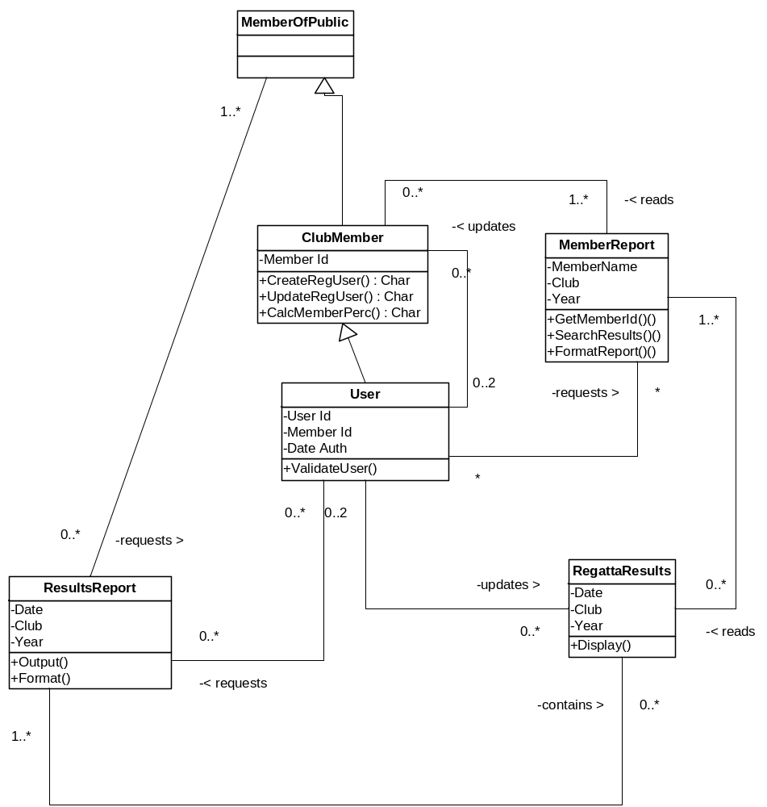
Figure C3.1 Class Diagram

The attributes are outlined in full for ClubMember, User and Regatta Results in section D3. Data Class Design.

D. Design Documentation

D1. Interface Design
As per Requirement 3.1 the system will be accessed via a standard web browser.
The web site main design will be in the form of frames and the basic outline will be as follows:
- The Top Banner section of the screen will have the title the CRA’s banner.
- The Links section will contain links to the Results page, contact details for the CRA and history of the CRA (see Use Case Description: Browse Website). It will also have a link to the Log in screen for the Registered Users Section.
- The Main Functionality section feature general information for a member of the Public. When the users select the Login screen, the login screen and the subsequent screens as outlined in the reminder of this section will appear in the Main Functionality section.
- Note that the colours used here are to illustrate the division between sections of the screen only – they do not reflect the actual colours to be used for the site.

<Top Banner>

<Links>

<Main Functionality>
Figure D.1 Basic Outline of Website Screen
As the second semester of the course features a Cognitive Science and Human Computer Interface module and a Web Design Fundamentals module, this section will outline only the basic outlines of the screens that will appear in the system. Project 2 will take account of the principles learned in the aforementioned modules.

The following screens outline the basic screen functionality for the User Interface and the Use Cases that the screen is associated with.

D1.1 Registered Users Login Section

CRA Registered Users Login Section

To login to this section you must be a Registered User of the County Rowing Club Association (CRA). Please contact the CRA for more details.

Please enter your Username and Password in the boxes provided:

User Name:

Password:

Figure D1.1 Login Screen for Registered Users

Use Case Description(s): Login
D1.2 Registered Users Section
Welcome to the CRA Registered Users Section!

Please select one of the following functions by clicking on the buttons:

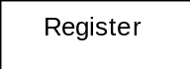 Enter/Update/View Club Members Details

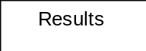 Enter Regatta Results

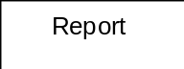 Create Report

Figure D1.2 Registered Users Options

Use Case Description(s): Login

D1.3 Enter/Update/View Club Member Details

CRA Registered Users Section

Enter/Update/View Club Members Details

To view club member’s details online, select the View button. You may Edit the details online for existing members.

To register or edit Club Members Details by attaching a spreadsheet, select the Update button

View
Update

Figure D1.3 Enter/Update/View Club Member Details Screen

Use Case Description(s): View Member Details, Register Members, Update Members

D1.4 Enter Regatta Results

CRA Registered Users Section

Enter Regatta Results

To edit existing results click this link. Edit the results in the spreadsheet format and click the Save button on the bottom of the screen.

If creating Regatta Results for the first time, please complete the following:

Regatta Date Race Placing

Crew 1 Crew 2 Crew 3 Crew 4

Cox Club

<select>
dd/mm/yyyy
<select>

<s>

<select>

<select>

<select>

<select>

<select>

<select>

Save Record

Figure D1.4 Enter Regatta Details Screen

Use Case Description(s): Enter Regatta Results, Update Regatta Results
D1.5 Create Report

CRA Registered Users Section

Create Report

Select the Club name and Member Name then hit the ‘Go’ button

Club Name Member Name

Result:

This member participated in out of regattas this season:

Regatta Participation Percentage is: %

<select>
<select>
Go

< list regattas this member participated in>

Figure D1.5 Create Report

Use Case Description(s): Create Report

D2. Architectural Design
The project will use a Three-Tier Client-Server Architecture.

First Tier
This will be the client and will be the user interface to the system. This will be a ‘thin’ client as the Users will be using PCs at home and implementing a ‘fat’ client would slow their processes down. This is the main reason a three-tier client-server architecture is being chosen over a two-tier one.

Second Tier
The Application Server will reside on the second tier. This tier will contain the data processing logic.

Third Tier
This is the database server tier. This tier will be responsible for data validation and database access.

Project 2 will involve researching and prototyping different hardware and software combinations to find the optimal choice. Shareware will also be looked at. Please see Section F – Project Proposal.

D3. Data Design

- A registered user will be a member of a club. They will have a Member Id and a User Id.

- A registered user will be the Club Secretary or Club Chairperson. There is a maximum of two registered users per club.

- As no club has an official club house, the club address will be deemed to be that of the first registered User of that club in the Users table.

- A Member Id will consist of one alpha character to denote the club and a 3 digit number e.g. S121. When the Users are adding details to the Member tables they must assign each of their club members a unique id. The system will validate that each Id is unique. This will occur when the User loads the Member details on the Enter/Update/View Member Details Screen.

- The Parent/Guardian information is split out from the Member table as this would cause repeating groups otherwise.

- The key in each table is underlined.

User Table

Field Name | Type | Length
User Id | Alphanumeric | 4
Member Id | Alphanumeric | 4
Password | Alphanumeric | 8
Date Approved | Date | 10

Member Table
Field Name | Type | Length
Member Id | Alphanumeric | 4
First Name | Character | 10
Last Name | Character | 15
Address 1 | Character | 20
Address 2 | Character | 20
Address 3 | Character | 20
Club | Character | 15
Date of Birth | Date | 10
Telephone | Numeric | 15
Parent/Guardian Id Form signed (Y/N) | Character | 1
Parent/Guardian Id | Character | 1
Registered User | Character | 4
Medical condition | Character | 30
Previous experience | Character | 30

Parent/Guardian Table
Field Name | Type | Length
Parent Id | Character | 4
Member Id | Character | 4
First Name | Character | 10
Last Name | Character | 15
Address 1 | Character | 20
Address 2 | Character | 20
Address 3 | Character | 20
Date of Birth | Date | 10
Telephone | Numeric | 15

Regatta Results Table
Field Name | Type | Length
Club Name | Character | 4
Date | Date | 10
Race | Character | 10
Placing | Character | 15
Team member 1 – First Name | Character | 10
Team member 1 – Last Name | Character | 15
Team member 2 – First Name | Character | 10
Team member 2 – Last Name | Character | 15
Team member 3 – First Name | Character | 10
Team member 3 – Last Name | Character | 15
Team member 4 – First Name | Character | 10
Team member 4 – Last Name | Character | 15
Cox – First Name | Character | 10
Cox – Last Name | Character | 15
Club

E. Testing Documentation

The Use Case Descriptions outlined in section D. Design Documentation will form the basis for testing the prototypes in Project Module 2.

Detailed test scripts for each prototype will be developed for Project Module 2.

F. Proposal for Project Module 2

My proposal for Project Module 2 in Semester 2 is to compare various ways to implement the new system. With reference to the Architectural Design, this will focus on:

- Client tier: compare various languages/tools to use to develop a robust front end. Dreamweaver was specified in the requirements. However if a more appropriate and cheaper development tool is available the CRA are willing to use it.

- Application Level tier: compare the languages to implement the business logic at the application level tier.

- Database tier: compare databases available and decide which would be most appropriate to use in this system based on cost, ease of interoperability. Databases analysed will be MySQL, Oracle and Microsoft Access.

- Shareware: shareware will be examined to see if any appropriate tool exists that would assist in implementing the new system.

- Prototyping: prototyping will be used to test out the above to come to a conclusion on what hardware and software is most appropriate. Important factors in the evaluation process will be:

  - ease-of-use
  - cost
  - scalability
  - reliability
  - performance

This proposal represents a big challenge for me as I have not worked on this type of system before.

G. Implementation Schedule

Analysis of various implementations will take place early in the semester.

Prototyping will begin to be developed starting the week of February 19th in the second semester.

At project end date, I plan to provide:

- Prototypes worked on.
- For each prototype, what was the hardware and software involved.
- A detailed report on the advantages and disadvantages of each.

Appendix A - Process Diagrams

A1. Login to Registration System

User Id
Go to Web Site
www.cra.com
Selected ‘Registered Users’ Section
Login to REGSYS
Pass-word

Invalid Login
Login Retry

Successful Login

REGSYS

Figure A.1 Logon to Registration System (REGSYS)
Figure A.1 illustrates how the user will log on to the registration system:
  - Open Internet Explorer or Netscape and go to the website www.cra.com (note: this may not be the actual web site name – this is a working name at present).
  - In the left hand column on the site their will be a ‘Registered Users Section’ link. Click once on this link).
  - The user login screen will be presented. Enter User Id and Password. These will be assigned to each user when training begins in mid-May 2007.
  - If either the user id or the password is entered incorrectly then the user will be prompted to re-enter this information. If it in entered incorrectly three times, then the system will prompt the user to enter the information for the fourth time with the warning that if the information is entered incorrectly again the user will be locked out of the system
  - If the login is validated then the user will be presented with the ‘Registered Users Section’ Screen (see Process Diagram 4.2).
  - The response time should be less than five seconds.

A.2. The Registration System Screen
REGSYS
Welcome to the CRA Registered Users Section!

Please select one of the following functions by clicking on the buttons:

Update Club Members Details

Enter Regatta Results

Create Report

Register
Results
Report

Figure A.2 Basic Screen Mock Up for the Registration System

Fig A.2 illustrates the three functions that will be provided through the Registered Users Section

- ‘Update Club Members Details’: see Requirement 3.3 and Requirement 3.4
- ‘Enter Regatta Results’: see Requirement 3.6
- ‘Create a Report’: see Requirement 3.7

A.3. Update Club Member’s Details

Details ok

MS Excel Member Details

Load Details

Confirm Update

Exceptions

Invalid Details

Message to User, Update Retry

Figure A.3 Update Club Members Details Diagram

- When the user clicks on the ‘Register’ button on the screen in Fig. A.2, he/she will attach the Microsoft Excel spreadsheet with the users details and click the ‘Load Details’ button.
- If the spreadsheet is filled in correctly then the system will prompt the user to confirm the update by hitting Enter to update or Cancel to cancel the update.
- If the spreadsheet is in the incorrect format, or has details filled in incorrectly or has duplicate members then the User will be prompted with a message advising him/her of the error and possible solutions to correct it.
- The member Delete function will occur in this part of the system; however this is not represented diagrammatically at this time.
- The response time should be less than ten seconds.

A.4. Enter Regatta Results

Date ok

Exception Team Complete Exception

Select Regatta

Enter Date (YYMMDD)

Re-enter Date

Invalid Date

Select Race

Select Club

Select Team Members x5
Team Incomplete

Complete Team

SUBMIT

Figure A.4 Enter Regatta Results

Please see Section 3.6.1 for a Description for this process.
The response time should be less than three seconds.

A.5 Create Report

Member Exists

Member Name

Check Member Exists

Create Report

Exception

Invalid Member

Re-enter Member Name

Figure A.5 Create Report Diagram

- When the user selects the Create Report button, the screen presented will involve the processing as illustrated in Fig A.5.
- The user can enter the member name in the box provided.
- The system will check if this member exists.
- If it does exist it will run the report.
- If it does not exist it will prompt the user to re-enter the name.
- The response time should be less than three seconds.

